Vermot-Desroches Matthias

Rapport de séance n°14

During this session, I made test on the obstacle detecting program and started to make new “floors” for the robot to put sensors and drivers on them.

I started by making a temporary floor with a plastic plate and some adhesive tape in order to do the final tests of the obstacle detecting program with ultrasound sensors. Here are pictures it:

You can see that everything is put to position and maintain by the tape, making this floor a fragile one, but since it is a temporary one, it does not really matter, what matters are the test.

So, after that, I uploaded the program and plugged the robot to make them. After the first one (consisting of just letting the robot go with large element on his way), I realized that not every robot’s wheels touched the ground, making it hard to turn at some point. I think that this problem will solve itself once we put the LiDAR ensemble on the robot, as the weight put on the suspension will increase.

Then, I decided to put smaller elements on his way and realized that the ultrasound sensors where placed too high to detect them. That meant that we would need to lower them later.

After that, I spoke with Mr Masson and we decided it was time to make other floors and mostly to put the motors’ driver at the lowest place possible, since we would most likely never touch it again

.

I chose to put the driver between the lower and upper part of the frame, as the cables are already being stretched a lot. Here is a picture of how I see the positioning and maintaining :

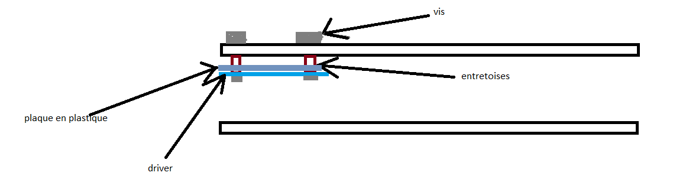

You can see that I would use a plastic support piece in order for the driver to not touch the screw or the frame since they are all in metal and their contact will create short-circuit. The struts are also here to prevent the contact.

I pierced new holes on the upper frame of the robot and tried to make a plastic support piece for the driver.

I had to redo the plastic support piece because the piece of plastic I used were either too small, or too dilated by the piercing. But Mr Masson then told me that it does not matter how many holes or how big they were on the piece. I will finish the plastic piece next week and probably wield the cables as they are too stretched, and the copper parts tend to not stay link with the driver.